Czech University of Life Sciences Prague
Faculty of Engineering
Department of Physics
Kamýcká 129, 16521 Prague 6, Czech Republic

19th International Workshop for Young Scientists

BioPhys Spring 2020

FIRST ANNOUNCEMENT

to be held
on 19th–21st May 2020 in Prague

under the auspices Assoc. Prof.. Ing. Jiří Mašek, PhD.,
Dean of the Faculty of Engineering

Co-organizers:

 | INCLUDEPICTURE "http://bps2013.ipan.lublin.pl/uploads/logo_pan_lublin.jpg" \* MERGEFORMATINET INCLUDEPICTURE "http://bps2013.ipan.lublin.pl/uploads/logo_pan_lublin.jpg" \* MERGEFORMATINET INCLUDEPICTURE "http://bps2013.ipan.lublin.pl/uploads/logo_pan_lublin.jpg" \* MERGEFORMATINET INCLUDEPICTURE "http://bps2013.ipan.lublin.pl/uploads/logo_pan_lublin.jpg" \* MERGEFORMATINET INCLUDEPICTURE "http://bps2013.ipan.lublin.pl/uploads/logo_pan_lublin.jpg" \* MERGEFORMATINET INCLUDEPICTURE "http://bps2013.ipan.lublin.pl/uploads/logo_pan_lublin.jpg" \* MERGEFORMATINET INCLUDEPICTURE "http://bps2013.ipan.lublin.pl/uploads/logo_pan_lublin.jpg" \* MERGEFORMATINET  |  | INCLUDEPICTURE "http://www.uniag.sk/tl_files/download/dokumenty/verejnost/loga/SPU_AJ.jpg" \* MERGEFORMATINET INCLUDEPICTURE "http://www.uniag.sk/tl_files/download/dokumenty/verejnost/loga/SPU_AJ.jpg" \* MERGEFORMATINET INCLUDEPICTURE "http://www.uniag.sk/tl_files/download/dokumenty/verejnost/loga/SPU_AJ.jpg" \* MERGEFORMATINET INCLUDEPICTURE "http://www.uniag.sk/tl_files/download/dokumenty/verejnost/loga/SPU_AJ.jpg" \* MERGEFORMATINET INCLUDEPICTURE "http://www.uniag.sk/tl_files/download/dokumenty/verejnost/loga/SPU_AJ.jpg" \* MERGEFORMATINET INCLUDEPICTURE "http://www.uniag.sk/tl_files/download/dokumenty/verejnost/loga/SPU_AJ.jpg" \* MERGEFORMATINET INCLUDEPICTURE "http://www.uniag.sk/tl_files/download/dokumenty/verejnost/loga/SPU_AJ.jpg" \* MERGEFORMATINET 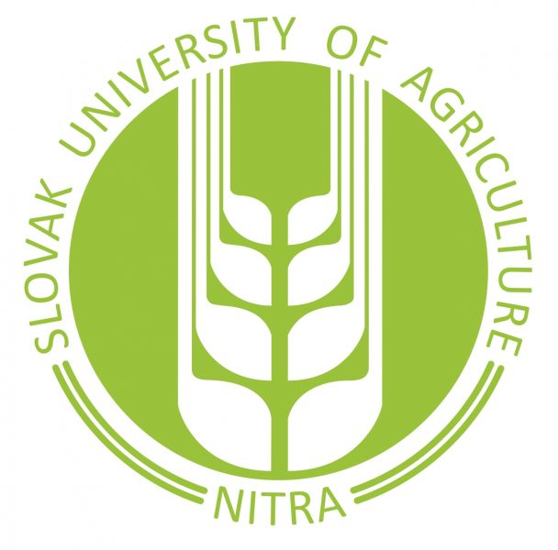 INCLUDEPICTURE "http://bps2013.ipan.lublin.pl/uploads/logo_godollo1.jpg" \* MERGEFORMATINET INCLUDEPICTURE "http://bps2013.ipan.lublin.pl/uploads/logo_godollo1.jpg" \* MERGEFORMATINET INCLUDEPICTURE "http://bps2013.ipan.lublin.pl/uploads/logo_godollo1.jpg" \* MERGEFORMATINET INCLUDEPICTURE "http://bps2013.ipan.lublin.pl/uploads/logo_godollo1.jpg" \* MERGEFORMATINET INCLUDEPICTURE "http://bps2013.ipan.lublin.pl/uploads/logo_godollo1.jpg" \* MERGEFORMATINET INCLUDEPICTURE "http://bps2013.ipan.lublin.pl/uploads/logo_godollo1.jpg" \* MERGEFORMATINET INCLUDEPICTURE "http://bps2013.ipan.lublin.pl/uploads/logo_godollo1.jpg" \* MERGEFORMATINET 

Dear friends and colleagues,

It is our privilege and great pleasure to invite you on behalf of organising institutions – Czech University of Life Sciences Prague (Czech Republic) together with The Bohdan Dobrzański Institute of Agrophysics of the Polish Academy of Sciences (Poland), Slovak University of Agriculture in Nitra (Slovakia) and Szent István University, Gödöllő, (Hungary) – to participate in the 19th International Workshop for Young Scientists "BioPhys Spring 2020" to be held in Prague on 19th – 21st May 2020.
The workshop is oriented on the deeper insight into the physical processes occurring in biological, agricultural and food systems. The workshop combines two basic tasks of international meeting: exchange of professional experience and integration of young people from different countries.
We coordially invite young scientists to participate in the BPS 2020 Workshop and to present results of your research in application of physical methods to agriculture, biology and/or life sciences.
The workshop is organised as an open English spoken event. One or two-pages abstracts of contributions will be published in the Book of Abstracts of the BPS 2020 Workshop.
It is my pleasure to invite you to spend a few days of May 2020 in a friendly atmosphere between young people in Prague.

Martin Libra
Chairman of the Organising Committee

SCIENTIFIC COMMITTEE
- Prof. Martin Libra, Czech University of Life Sciences, Prague, Czech Republic, chairman
- Prof. Jiří Blahovec, Czech University of Life Sciences, Prague, Czech Republic
- Prof. Józef Horabik, Institute of Agrophysics PAS, Lublin, Poland
- Prof. István Farkas, Szent István University, Gödöllő, Hungary
- Assoc. Prof. Vlasta Vozárová, Slovak University of Agriculture in Nitra, Slovak Republic
- Assoc. Prof. Ľubomír Kubík , Slovak University of Agriculture in Nitra, Slovak Republic
ORGANISING COMMITTEE AND CONTACT:

Martin Libra – chairman
Phone: +420 224383284
libra@tf.czu.cz

Jan Sedláček – vice-chairman
Phone: +420 224383286
sedlacek@tf.czu.cz

Magdalena Lahodová – secretary
Phone: +420 224383290
lahodova@tf.czu.cz

Jana Šafránková – secretary
Phone: +420 224383286
janicka.safrankova@gmail.com

Contact Address:
Czech University of Life Sciences Prague
Faculty of Engineering
Department of Physics
Kamýcká 129
16500 Prague 6
Czech Republic
http://www.tf.czu.cz/

DEADLINES

April 2, 2020 | Registration
April 2, 2020 | Submission of abstract

ABSTRACT

Instructions for abstract preparation – available in the attached file

REGISTRATION

Registration form – available in the attached file

LOCATION
Czech University of Life Sciences Prague, Faculty of Engineering, Round Hall

